As I sit in heaven and watch you everyday, I try to let you know with signs I never went away. I hear you when you’re laughing and watch you as you sleep, I even place my arms around you to calm you as you weep. I see you wish the days away begging to have me home, so I try to send you signs so you know you are not alone. Don’t feel guilty that you have Life that was denied to me; heaven is truly beautiful, just you wait and see. So live your life, laugh again, enjoy yourself, be free. Then I know with every breath you take you’ll be taking one for me.
Jeannie’s family wishes to give a heartfelt thanks to those who have contributed to Jeannie’s care over the last ten years. A special thanks to those who have expressed warm wishes during this extremely hard time.
Arrangments entrusted to:
Jeannie Faye McDeVitt
Sunrise 02/06/1960
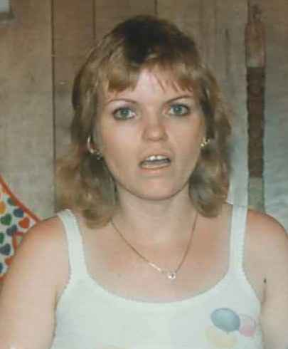
Sunset – 06/13/2015

Jeannie passed on to her new life on Saturday, June 13, 2015. She was born in Tacoma General Hospital to Russell Thompson and Nancy Smith on February 6th, 1960.
She moved to California as a baby for a few years and then moved back to Washington. She graduated from Tenino High School and signed up with the U.S. Navy. Her military career was cut short when she was diagnosed with Type I diabetes. This began her life long journey with multiple illnesses. She was cheerful and courageous through it all, andmade us all laugh and smile.
She was a loving mother to Todd Mallett and a doting grandmother to Joshua James Mallett. She married the love of her life, Darrell McDevitt on July 4th, 1985 and shared almost 30 years of a partnership that can only be envied.
Jeannie lived and traveled in several states, including Kansas, Colorado, Hawaii, Virginia, North Carolina but returned to Washington for the last 30 plus years. She loved her many pets and was an avid Coca Cola collector. In 2005 another roadblock was put in her wayâ€¦blindness. To honor Jeannie, her corneas were donated so that someone somewhere could be given the gift of sight. A part of her will still be here seeing the blue skies, the green trees and rainbows after the storms.
In 2011 she was diagnosed with breast cancer. Jeannie fought that tough battle through 2012 with her usual humor and fighting spirit. She made sure she still lived and fully participated in her many activities.
Jeannie also collected items and clothes with hearts which was so appropriate as she was so soft hearted and would take care of and/or help people or animals as much as she could. She loved music and Stevie Nicks was her favorite.
In addition to her husband, son, grandson, and mother, she leaves behind,brothers, Curt Thompson, G. Scott Thompson, Danny Long; her sisters, Lori Clark, J.Janette Moser, Melissa Long, Her step-family: John , Leonard, Alan and Juanita Velasquez, step-mother, Ila Szabo; she was step-mother to Amy, Andrea, John and Ryan McDevitt, along with 15 nieces and nephews, and a host of other relatives and friends.
We gather here to remember her wonderful sense of humor.
We gather here on Friday, June 19th, 2015 to
CELEBRATE JEANNIE McDEVITT’s LIFE.

CELEBRATION ORDER
Welcome / Greeting
Opening Remarks
Life Sketch by Ron Yeager
Open Sharing
Balloon Release & Music

